Experiment NO:1

AIM: Write a program for matrix addition

PROGRAM:

X = [[12,7,3],

    [4 ,5,6],

    [7 ,8,9]]

Y = [[5,8,1],

    [6,7,3],

    [4,5,9]]

result = [[0,0,0],

         [0,0,0],

         [0,0,0]]

for i in range(len(X)):

   for j in range(len(X[0])):

       result[i][j] = X[i][j] + Y[i][j]

for r in result:

   print(r)

OUTPUT:

[17, 15, 4]

[10, 12, 9]

[11, 13, 18]

Experiment NO: 2

AIM: Write a program for matrix multiplication

PROGRAM:

X = [ [1,2],[3,4],[4,5] ]

Y = [ [1,2,3],[4,5,6] ]

result = [ [0,0,0],[0,0,0],[0,0,0] ]

my_list = []

for i in range( len(X) ):

   for j in range(len(Y[0])):

       for k in range(len(Y)):

           result[i][j] += X[i][k] * Y[k][j]

for r in result:

   print(r)

OUTPUT:

[9, 12, 15]

[19, 26, 33]

[24, 33, 42]

EXPERIMENT NO: 3

AIM: Write a program for identity matrix

PROGRAM:

def Identity(size):

  for row in range(0, size):

    for col in range(0, size):

      if (row == col):

        print("1 ", end=" ")

      else:

        print("0 ", end=" ")

    print()

size = 5

Identity(size)

OUTPUT:

1 0 0 0 0

0 1 0 0 0

0 0 1 0 0

0 0 0 1 0

0 0 0 0 1

EXPERIMENT NO:4

AIM: Write a program for determinant of the matrix

PROGRAM:

import numpy as np

arr = np.array([[30, 12], [20, 11]])

print("Numpy Matrix =")

print(arr)

determinant = np.linalg.det(arr)

print("\nThe Determinant of 2 * 2 Matrix =")

print(int(determinant))

OUTPUT:

Numpy Matrix =

[[30 12]

[20 11]]

The Determinant of 2 * 2 Matrix =

90

EXPERIMENT NO:5

AIM: Program for import and viewing the iris pandas

PROGRAM:

A)

import pandas as pd

csv_url = 'https://archive.ics.uci.edu/ml/machine-learning-databases/iris/iris.data'

col_names = ['Sepal_Length','Sepal_Width','Petal_Length','Petal_Width','Class']

iris = pd.read_csv(csv_url, names = col_names)

print(iris.head())

print(iris.tail())

print(iris.dtypes)

OUTPUT:

Sepal_Length Sepal_Width Petal_Length Petal_Width Class

0 5.1 3.5 1.4 0.2 Iris-setosa

1 4.9 3.0 1.4 0.2 Iris-setosa

2 4.7 3.2 1.3 0.2 Iris-setosa

3 4.6 3.1 1.5 0.2 Iris-setosa

4 5.0 3.6 1.4 0.2 Iris-setosa

Sepal_Length Sepal_Width Petal_Length Petal_Width Class

145 6.7 3.0 5.2 2.3 Iris-virginica

146 6.3 2.5 5.0 1.9 Iris-virginica

147 6.5 3.0 5.2 2.0 Iris-virginica

148 6.2 3.4 5.4 2.3 Iris-virginica

149 5.9 3.0 5.1 1.8 Iris-virginica

Sepal_Length float64

Sepal_Width float64

Petal_Length float64

Petal_Width float64

Class object

dtype: object

B)

csv_url = 'https://archive.ics.uci.edu/ml/machine-learning-databases/iris/iris.data'

iris = pd.read_csv(csv_url, header = None)

col_names = ['Sepal_Length','Sepal_Width','Petal_Length','Petal_Width','Species']

iris =  pd.read_csv(csv_url, names = col_names)

iris.dtypes

iris.head()

OUTPUT:

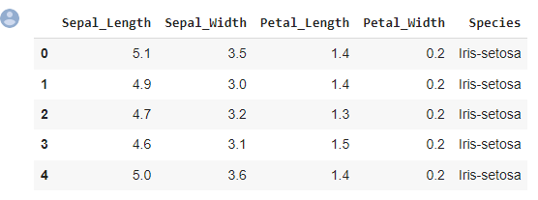

C)

iris.head()

iris.index

iris.sort_index(axis=1, ascending=False).head(10)

iris.sort_values(by='Petal_Width').head(10)

OUTPUT:

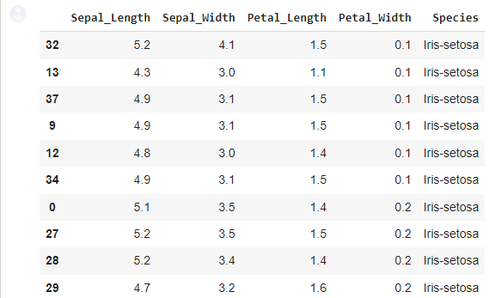

D)

iris['Sepal_Length'].head()

iris[0:5]

OUTPUT:

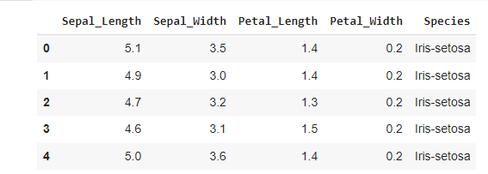

E)

iris.loc[0:10, ['Sepal_Length', 'Petal_Length']]

iris.loc[0, ['Sepal_Length', 'Petal_Length']]

iris.loc[0, 'Petal_Length']

iris['Petal_Length'].head()

iris.Sepal_Length.head()

iris.loc[0]

OUTPUT:

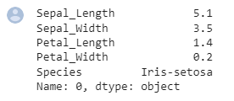

F)

iris.iloc[0:3, 0:4]

iris.iat[0,0]

OUTPUT:

5.1

G)

iris.head()

OUTPUT:

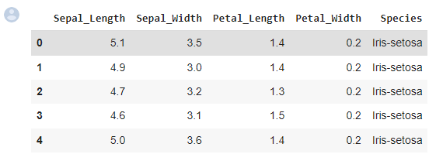

H)

iris.index

OUTPUT:

RangeIndex(start=0, stop=150, step=1)

I)

iris.columns

OUTPUT:

Index(['Sepal_Length', 'Sepal_Width', 'Petal_Length', 'Petal_Width', 'Species'], dtype='object')

J)

iris.sort_index(axis=1, ascending=False).head(10)

OUTPUT:

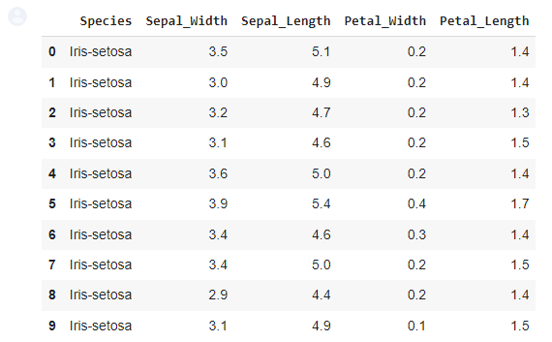

K)

iris.sort_values(by='Petal_Width').head(10)

OUTPUT:

